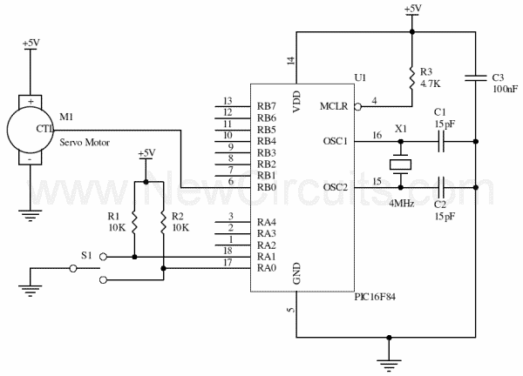
For above circuit, which programming I needed to use??? A or B
A

Include "modedefs.bas"
si var PORTA.0
pos var byte
servo var byte
cont var byte
trisb = 0
start:
serin si,N2400,servo,pos
for cont = 0 to 50
pulsout servo,pos
pause 15
next cont
goto start

B

Symbol porta = 5
b3 = 150
start:
Peek porta,b0
If bit0 = 0 Then sweepl
If bit1 = 0 Then sweepr
Pulsout 0,b3
Pause 18
Goto start
sweepl:
b3 = b3 + 1
Pulsout 0,b3
Pause 18
If b3 > 200 Then hold1
Goto start
sweepr:
b3 = b3 - 1
Pulsout 0,b3
Pause 18
If b3 < 100 Then hold2
Goto start
hold1:
b3 = 200
Goto start
hold2:
b3 = 100
Goto start

