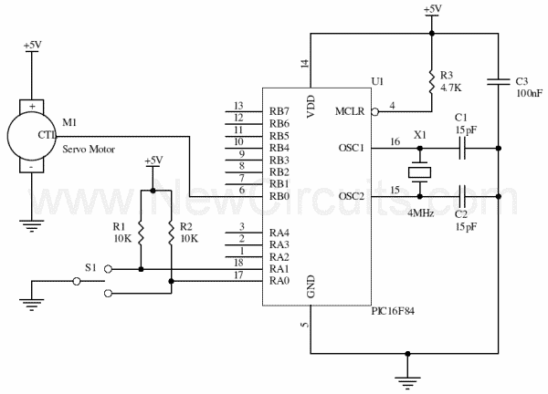
Include "modedefs.bas"
si var PORTA.0
pos var byte
servo var byte
cont var byte
trisb = 0
start:
serin si,N2400,servo,pos
for cont = 0 to 50
pulsout servo,pos
pause 15
next cont
goto start

