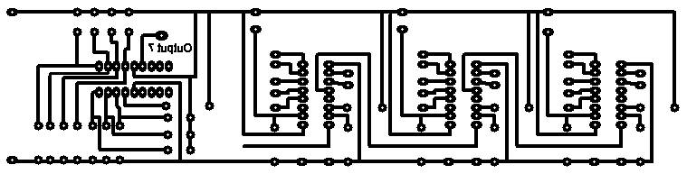
PIC 16F627

Some of the pads look like they are touching but they are not. The picture has distorted when transferred from PCB Wizard
There is a pad here on the PCB. This has a wire link from the output to the clock on the first 4026.

The other 4026s work in sequence. Its just the first counts by its self at regular intervals

