Simulation results
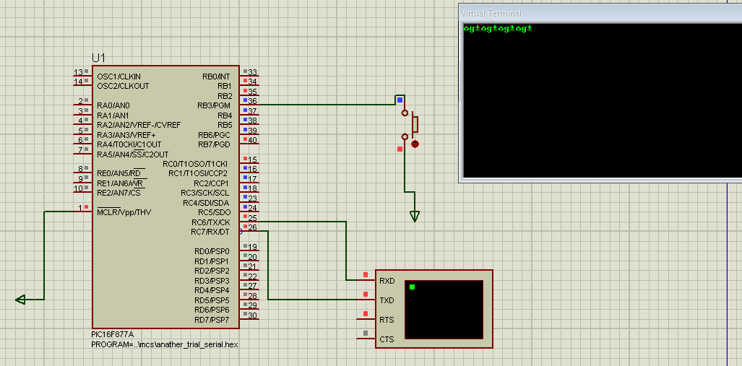
define osc 20
char var byte
trisb=1
trisc=0
RCSTA=$90
TXSTA=$24
SPBRG=25
start:
hserin 1000,mainloop,[char]
mainloop:
if portb.3=1 then
hserout ["door is opened",13,10]
hserout [char]
endif
goto start
end

program UART
dim uart_rd as byte

main:
UART1_Init(9600) ' Initialize UART module at 9600 bps
Delay_ms(100) ' Wait for UART module to stabilize

UART1_Write_Text("Ready")
UART1_Write(10) ' Line Feed
UART1_Write(13) ' Carriage Return

while (TRUE) ' Endless loop
if (UART1_Data_Ready() <> 0) then ' If data is received,
uart_rd = UART1_Read() ' read the received data,
UART1_Write(uart_rd) ' and send data via UART
end if
wend

