OSD-232+TM
Version 1.01
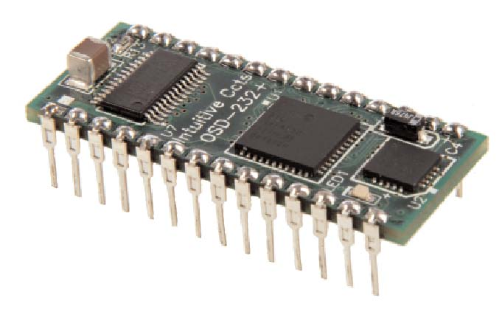
Copyright © 2009 Intuitive Circuits, LLC
OSD-232+™ is a single channel on-screen composite video character and graphic overlay device in the form factor of a 28 pin .6” dip socket. From any RS-232 or TTL source, such as a PC or microcontroller, control the display of 30 columns by 12 rows (NTSC) or 15 rows (PAL) of information directly onto an incoming composite video source. OSD-232+™ can overlay characters and graphics onto either an incoming video source or self-generated background screen. OSD-232+™ has 256 definable 12 x 18 pixel characters. Graphic images (such a logos) can be imported to create on-screen sprites. OSD-232+™ firmware upgrades are supported via a PC connection.
Included with OSD-232+™ is a demonstration utility, firmware update utility, and font editing software. An optional evaluation board EB-OSD-232+™ with connectors and wall power supply is also available.
Dimensions: | 1.54” L x .6” W x .3” H
Weight: | < .1 oz.
Input voltage: | 5.0 volts DC +/- 5% (150 ma max)
Operating temperature: | -40C to +85C (extended temperature range standard)
Text area: | 30 columns by 12 rows (NTSC) or 15 rows (PAL)
 | Due to monitor over-scan a minimum of 26 of the 30
 | columns and 11 of 12 rows (NTSC) are visible on-screen
Character set: | 256 definable characters. 12 x18 pixels per character.
Sprites: | 16 definable graphic sprites
Video format: | Composite video
Video level: | 1 volt peak to peak
Video impedance: | Input 75 ohm, output 75 ohm resistively terminated

RS-232 serial or TTL input: 9600 or 19200 baud, 8 data bits, 1 stop bit, inverted data Power up defaults: Overlay mode, cleared screen, cursor position top left (0,0), visible text, character blink off, character invert off, character background off
See Figure 1. on page 4 for a diagram.
Pin# | Label | Description
1 | Video In | Video input
2 | Video Gnd | Video ground (both video input and output share)
3 | VDC Gnd | DC ground
4 | +5 VDC | +5 DC source +/- 5% (150ma max.) DO NOT EXCEED 5 VOLTS! If required bypass this pin to ground with a 100uf aluminumelectrolytic capacitor
5 | LOS | Loss of sync of video inputLow = video present on inputHigh = no video present on input
6 | I2C Data | I2C data (future enhancement)
7 | I2C Clock | I2C clock (future enhancement)
8 | Reserved | Reserved pin
9 | Reserved | Reserved pin
10 | Reserved | Reserved pin
11 | GPIO 0 | General purpose I/O (future enhancement)
12 | GPIO 1 | General purpose I/O (future enhancement)
13 | RS-232 Rx | RS-232 (or TTL) receive
14 | RS-232 Tx | RS-232 transmit
15 | RS-232 RTS | RS-232 request to send (future enhancement)
16 | RS-232 CTS | RS-232 clear to send (future enhancement)
17 | RS-232 Gnd | RS-232 ground
18 | Input 0 | RS-232 baud rate* No connection = 9,600 baud Pulled to ground = 19,200 baud
19 | Input 1 | NTSC or PAL video format* No connection = NTSC Pulled to ground = PAL
20 | Input 2 | Display font screen*Pulled to ground to display font screen
21 | Input 3 | Firmware flash update*Pulled to ground to enter firmware flash update
22 | Input 4 | Unused pin
23 | Input 5 | Unused pin
24 | Input 6 | Unused pin
25 | Input 7 | Unused pin
26 | HSYNC | Horizontal sync output of video inputLow = video horizontal sync intervalHigh = not video horizontal sync interval
27 | VSYNC | Vertical sync output of video inputLow = video vertical sync intervalHigh = not video vertical sync interval
28 | Video Out | Video output

* Note: Input 0 – Input 3 are only checked at power-up
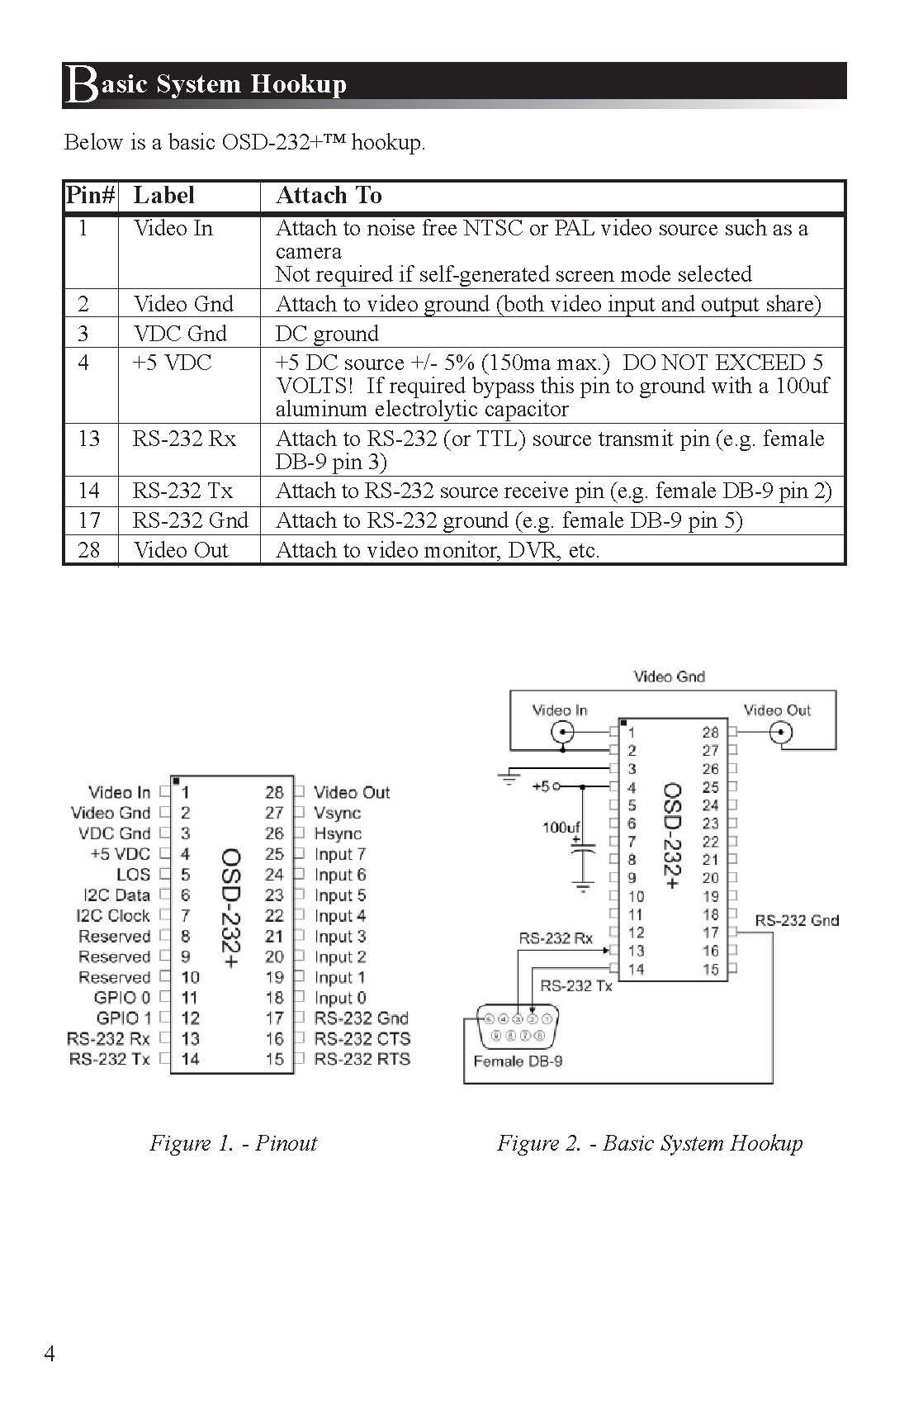
OSD-232+™ RS-232 protocol settings are 9600 or 19200 baud, 8 data, 1 stop, no parity, no flow control.
Communicating with OSD-232+™ requires either sending individual displayable font characters (0x00h – 0xDFh) or sending a command ID value followed by the appropriate number of parameters (see table below.) Command values are in hexadecimal (e.g. 0xE1h = 225 decimal).
Command | Value | # of Params | Description
UNUSED | 0xE0h | N/A | UNUSED
Set Video Format | 0xE1h | 1 | Set the video format (0-1) 0 = NTSC 1 = PAL Only required to override Input 1 pin
Set Overlay Mode | 0xE2h | 1 | Set the video overlay mode (0-2) 0 = Auto switch based on valid video input [default] 1 = Overlay text and graphics with incoming video only (external sync) 2 = Overlay text and graphics with self-generated background screen only (internal sync)
Clear Screen | 0xE3h | 0 | Clear the entire screen with spaces (uses character in font position 00h)
Show / Hide Overlay | 0xE4h | 1 | Show or hide the text and graphics overlay (0-1) 0 = Hide text and graphics 1 = Show text and graphics [default]
Set Cursor Position | 0xE5h | 2 | Set the cursor position Byte 0 = X (0-29) Byte 1 = Y NTSC (0-12), PAL (0-15)
Set Character Blink Attribute | 0xE6h | 1 | Set character blink attribute (0-1) 0 = Off [default] 1 = On Applies to all characters drawn after the command is sent
Set Character Invert Attribute | 0xE7h | 1 | Set character invert attribute (0-1) 0 = Normal (white pixels display white, black pixels display black) [default] 1 = Invert (white pixels display black, black pixels display white) Applies to all characters drawn after the command is sent

Command | Value | # of Params | Description
Set Character Background Attribute | 0xE8h | 1 | Set character background attribute (0-1) 0 = Sets the background pixels of the character to the incoming video [default] 1 = Sets the background pixels of the character to the background mode brightness (0xF7h) Note: During internal sync mode, the background attribute behaves as if it is set to 1 Applies to all characters drawn after the command is sent
Draw Upper Range Character | 0xE9h | 1 | Draw one upper range font character at the current cursor position (0xE0-0xFF)
Draw Sprite | 0xEAh | 1 | Draw one sprite at the current cursor position (0-15)
Wait for VBLANK | 0xEBh | 1 | Wait for VBLANK before proceeding Byte 0 = Pre-delay in milliseconds (0-128) This is a forced delay before VBLANK detection occurs allowing the user time to send characters to be drawn during VBLANK.
Set Screen Horizontal Position Offset | 0xECh | 1 | Set Screen Horizontal Position Offset [default 53] 0 = Farthest left (-32 pixels) 32 = No horizontal offset 63 = Farthest right (+31 pixels)
Set Screen Vertical Position Offset | 0xEDh | 1 | Set Screen Vertical Position Offset [default 29] 0 = Farthest up (-16 pixels) 16 = No vertical offset 31 = Farthest down (+15 pixels)
UNUSED | 0xEEh 0xF3h | N/A | UNUSED
Set Pixel Rise and Fall Time | 0xF4h | 1 | Set pixel rise and fall time—typical transition times between adjacent OSD pixels (0-5) 0 = 20ns (maximum sharpness/maximum cross-color artifacts) 1 = 30ns 2 = 35ns 3 = 60ns [default] 4 = 80ns 5 = 110ns (minimum sharpness/ minimum cross-color artifacts)

Command | Value | # of Params | Description
Set Pixel Switching Time | 0xF5h | 1 | Set pixel insertion mux switching time–typical transition times between input video and OSD pixels (0-5) 0 = 30ns (maximum sharpness/maximum cross-color artifacts) 1 = 35ns 2 = 50ns 3 = 75ns [default] 4 = 100ns 5 = 120ns (minimum sharpness/minimum cross-color artifacts)
Set Row Brightness Black and White Levels | 0xF6h | 3 | Set the row brightness black and white levels Byte 0 = Row number: NTSC (0-12), PAL (0-15) Byte 1 = Character black level % of OSD white level (0-3) 0 = 0% [default] 1 = 10% 2 = 20% 3 = 30% Byte 2 = Character white level % (0-3) 0 = 120% 1 = 100% 2 = 90% [default] 3 = 80%
Background Mode Brightness | 0xF7h | 1 | Set background mode brightness for external mode (overlay) character background frame and internal mode (no video) background screen (0-7) 0 = 0% 1 = 7% 2 = 14% [default] 3 = 21% 4 = 28% 5 = 35% 6 = 42% 7 = 49%
UNUSED | 0xF8h 0xFAh | N/A | UNUSED
Display System Information | 0xFBh | 1 | Display system information on-screen 0 = Information screen* (input settings, software version, etc.) 1 = Font screen (font map) * Partial ASCII character font must be installed

Command | Value | # of Params | Description
Soft Reset | 0xFCh | 0 | Reset the OSD-232+™ to default (power-up) settings
Define Sprite (NVM Setting*) | 0xFDh | 4 | Define a sprite in non-volatile memory Byte 0 = Sprite # (0-15) Byte 1 = Start font table memory position (0-255) Byte 2 = Sprite width in characters (1-30) Byte 3 = Sprite height in characters NTSC (1-13), PAL (1-16) Returns: <cr><lf> (Must wait for before continuing to next sprite)
Define Font Character (NVM Setting*) | 0xFEh | 56 | Define a character in non-volatile font table memory Each character is 12 x 18 pixels Each pixel consists of 2 bits: 00 = black 10 = white x1 = transparent (pass video though) Byte 0 = Font table position to fill (0-255) Byte 1-54 = 54 bytes – 3 bytes per character row, 18 rows Byte 55 = End byte flag (0xAAh) Returns: <cr><lf> (Must wait for before continuing to next character)
Read Data | 0xFFh | 1 | Read data from the OSD-232+™ Byte 0 = Read request type 0x00h = Verify RS-232 connection Returns: “ok”<cr><lf> if connected 0x01h = Get firmware version Returns: Firmware version number e.g. “1.01”<cr><lf> 0x02h = Get board Input pin 0 - 7 settings Returns: “XXXXXXXX”<cr><lf> (“0” = off, “1” = on) 0x03h = Get video input status Returns: “X”<cr><lf> (“0” = no sync, “1” = sync)

Example: Clearing The Screen
Send 0xE3h - Clear the entire screen with spaces
Example: Sending Text
Send 0xE5h, 0x00h, 0x00h - Set cursor position 0, 0 Send "Hello world!" - Send ASCII text
Example: Sending Blinking Text
Send 0xE5h, 0x00h, 0x00h - Set cursor position 0, 0
Send 0xE6h, 0x01h - Set character blink attribute (ON)
Send "Blinking text!" - Send ASCII text
Send 0xE6h, 0x00h - Set character blink attribute (OFF)
Example: Drawing Graphic Sprite #2 At Cursor Position 6, 4
Send 0xE5h, 0x06h, 0x04h - Set cursor position 6, 4
Send 0xEAh, 0x02h - Draw sprite #2 (defined in font editor normally)
Below is the OSD-232+™ default font. Use the supplied font editor software to create your own or modify the default font. The left column is the high nibble in hexadecimal. The top row is the low nibble in hexadecimal. For example the hourglass character is 0xFCh (252 decimal).
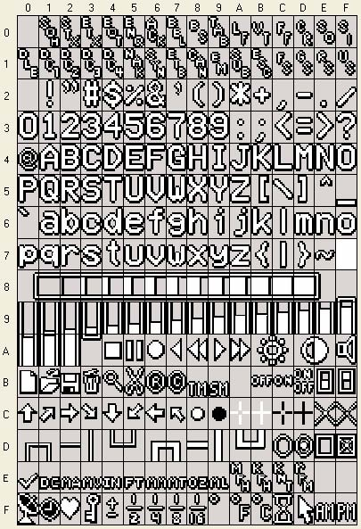
To download the OSD-232+™ Font Editor PC Utility and Demonstration Application go to the Intuitive Circuits secure download page at
http://www.icircuits.com/store/downloads_secure.php
Login: (Contact Intuitive Circuits) Password: (Contact Intuitive Circuits)
Please do not share the login and password with others.
- Download the Font Editor.zip file then unzip the files into a temporary folder
- Run setup.exe
- After the installation is complete the temporary folder can be removed
- Repeat this process for OSD-232+ Demonstration Utility.zip
- The program shortcuts are located on the computer desktop and in the Start>>Programs>>Intuitive Circuits folder.

PC System Requirements: Microsoft Windows 2000 operating system or later with minimum 1024 x 768 video screen resolution and one RS-232 serial port (or USB to RS-232 converter).
Problem | Solution
Green LED off (won’t power up) | • Verify power and ground connected to proper OSD-232+™ pins • Verify power supply outputting 5.0 volts DC +/- 5%
Screen text is skewed or unreadable | • Verify the OSD-232+™ video input has a valid, noise free, video signal
Garbage characters on screen or text not displayed | • Verify RS-232 source connected to proper OSD-232+™ pins • Verify communication baud rate 9,600 or 19,200 • Enable Input 2 to generate the font test screen • Use the supplied PC demonstration utility to verify the unit is working properly

If the product fails to perform as described in our product description or specification, within 1 year from the date of shipment to the buyer, we will repair or replace the product and/or accessories originally supplied. Failure due to improper installation, misuse, abuse or accident is not covered by this warranty. Incidental and consequential damages are not covered by this warranty. The buyer must first obtain a Return Material Authorization number by calling (248) 588-4400, or send email to support@icircuits.com. Ship the defective product (with RMA number) to Intuitive Circuits, 3928 Wardlow Ct., Troy, MI 48083, freight prepaid.
Intuitive Circuits, LLC
3928 Wardlow Ct.
Troy, MI 48083
Voice: (248) 588-4400
Fax: (248) 588-4455
http://www.icircuits.com

