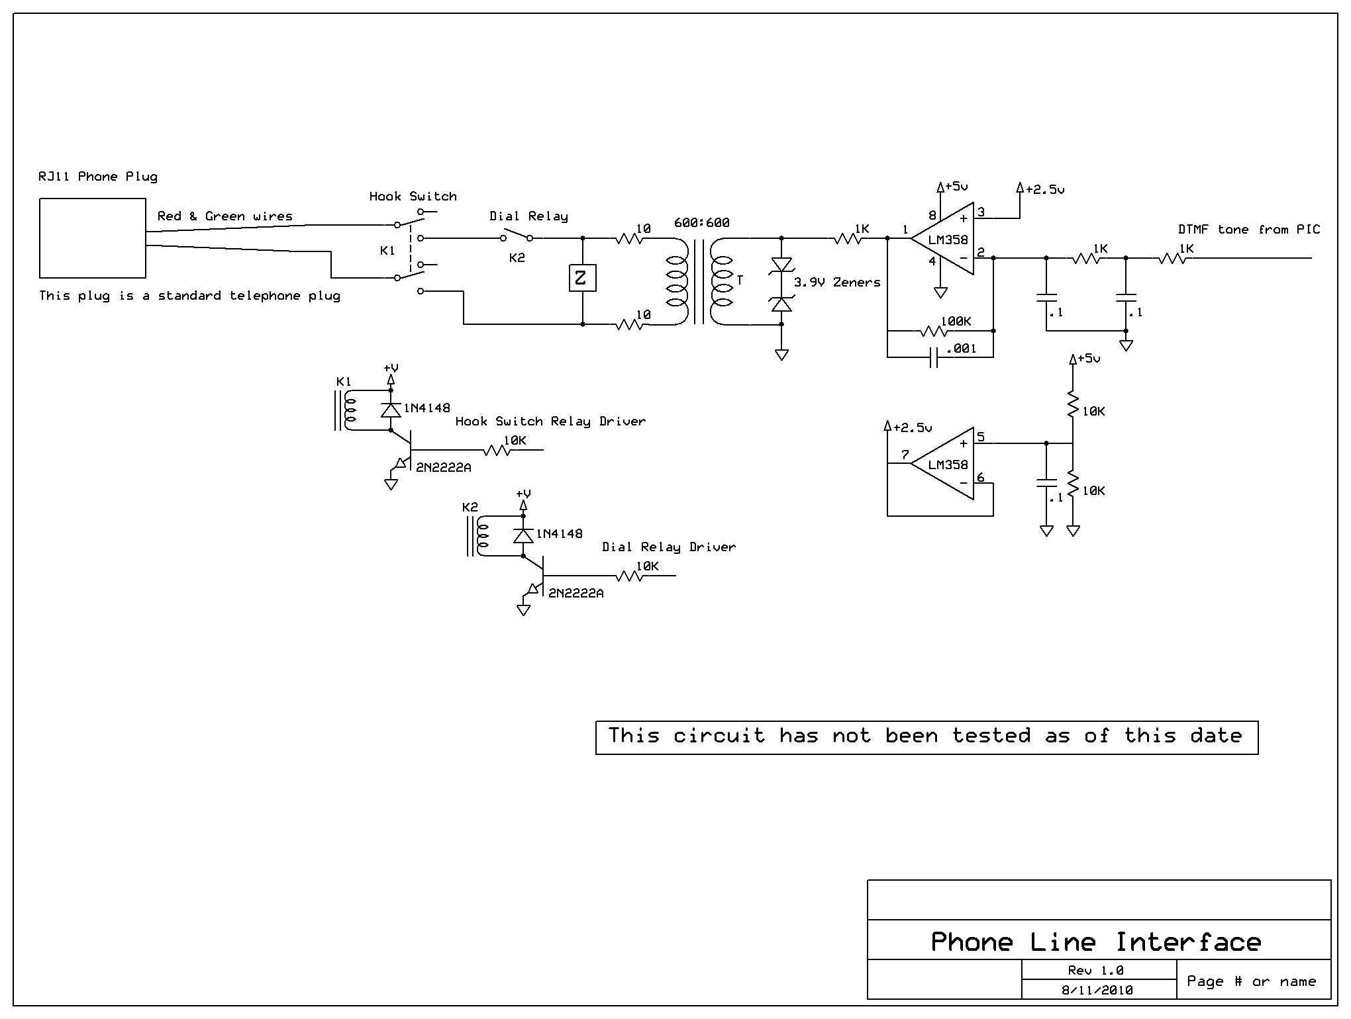

Sequence of events:

PIC receives an activation
PIC applies a high to K1’s driver circuit
Pause 250ms
PIC applies a high to K2’s driver circuit (We are now on the phone line)
Pause 250ms
PIC sends DTMF tones out onto phone line (This is the phone number being dialed)
Pause 3-5 seconds allowing someone to answer the phone
Message or whatever communications needs to be sent is sent
When call is completed:
PIC applies a low to both K1’s and K2’s driver circuits (We are now off the phone line)

Please note that I am providing very basic information here. You will need to determine how you want your project to work.

Professional alarm dialers have a sequence of events like this:
Panel is activated
Line seizure relay disconnects “house phones”
Dial relay is activated and now system is fully on the line
Panel “listens” for dial tone (350 & 440hz tones)
Dials phone number
Waits & listens for proper “handshake” tone from receiver
If proper tone is heard, then data is transmitted
A “kissoff” tone is sent by the receiver once it receives the data.
If there is any more data to be sent then the send data and kissoff process is repeated until all
messages are received. Then the panel hangs up.

There are several types of data transmissions we use. Which one is usually determined by the type of system and the installers preference.

